- \Operation\Downstream machine\Downstream machine
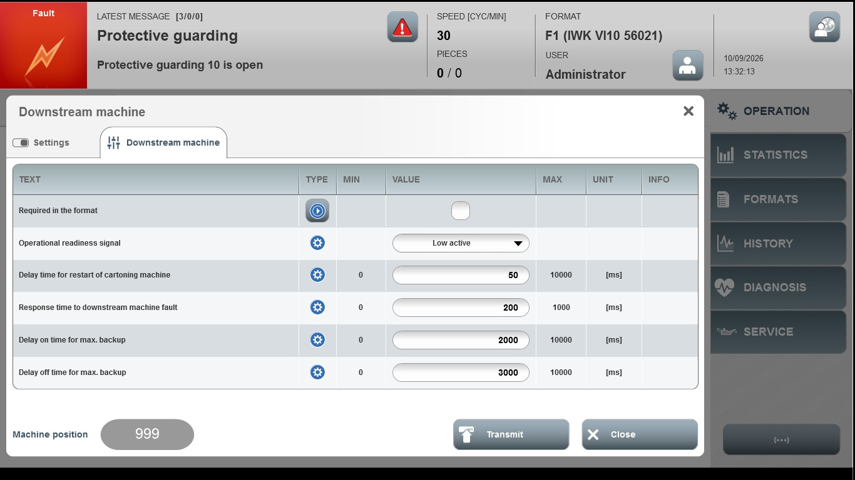
Acceptance criterion | Limits | Pass / Fail: Dev-No. | Date | Initials
Screen matches screenshot | N / A
Delay time for restart of cartoning machine | 0...10000
Response time to downstream machine fault | 0...1000
Delay on time for max. backup | 0...10000
Delay off time for max. backup | 0...10000

